Experiment – 1

Aim: To design and simulation of half adder and full adder using different types of modeling.
Software Used: AMD Vivado 2023.2
Theory:
1. Half Adder: The half adder is a basic building block of adding two numbers as two inputs and produce out two outputs. The adder is used to perform OR operation of two single bit binary numbers. The augent and addent bits are two input states, and 'carry' and 'sum 'are two output states of the half adder.
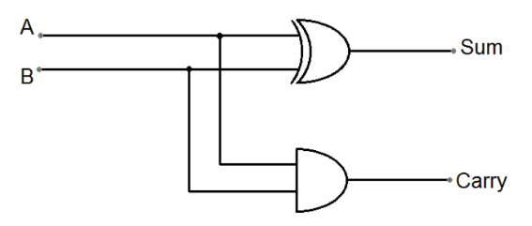
Table 1.1 Truth Table of Half Adder
A | B | Sum | Carry
0 | 0 | 0 | 0
0 | 1 | 1 | 0
1 | 0 | 1 | 0
1 | 1 | 0 | 1
Fig 1.1 Circuit Diagram of Half Adder
In the above table, 'A' and' B' are the input states, and 'sum' and 'carry' are the output states. The carry output is 0 in case where both the inputs are not 1. The least significant bit of the sum is defined by the 'sum' bit. The design equations of the sum and carry are as follows:
Sum =A'B + AB' or A(xor)B
Carry = A.B
From this, a half adder circuit can be easily constructed using one XOR gate and AND gate.
2. Full Adder: The half adder is used to add only two numbers. To overcome this problem, the full adder was developed. The full adder is used to add three 1-bit binary numbers A, B, and C_{in}. The full adder has three input states and two output states i.e., sum and carry.
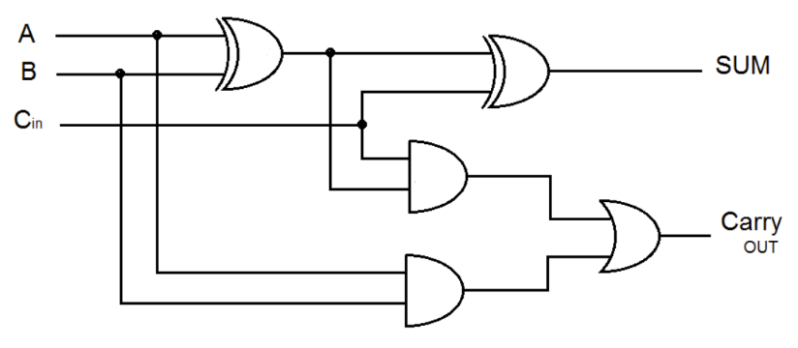
Table 1.2 Truth Table of Full Adder
A | B | C_{in} | Sum | Carry
0 | 0 | 0 | 0 | 0
0 | 0 | 1 | 1 | 0
0 | 1 | 0 | 1 | 0
0 | 1 | 1 | 0 | 1
1 | 0 | 0 | 1 | 0
1 | 0 | 1 | 0 | 1
1 | 1 | 0 | 0 | 1
1 | 1 | 1 | 1 | 1
Fig 1.2 Circuit Diagram of Full Adder

In the above table, 'A', ' B' and ‘C_{in}’ are the input states, and 'sum' and 'carry' are the output states. The design equations of the sum and carry are as follows:
Sum =A'B’C_{in} + A'B C_{in} + AB' C_{in}' + ABC_{in} or A(xor)B(xor) C_{in}
Carry = AB + BC_{in} + C_{in}A
Verilog Code:
1. Half Adder:

2. Full Adder:

Test Bench Code:
1. Half Adder:
2. Full Adder:

RTL Schematic:
1. Half Adder:
2. Full Adder:

Output Waveform:

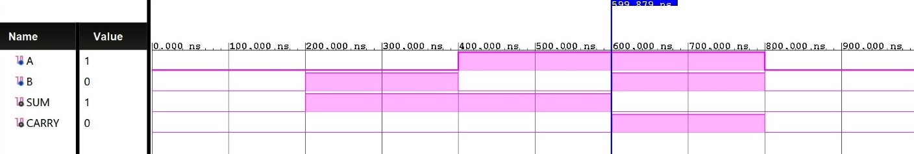
Fig 1.9: Half Adder – Output Waveform

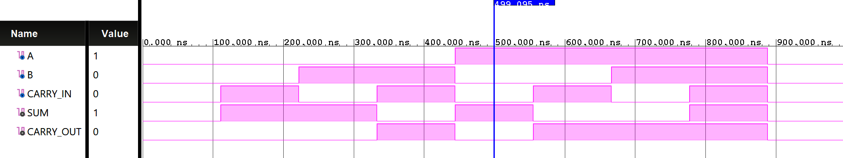
Fig 1.10: Full Adder – Output Waveform

Result: The half adder and full adder circuits has been designed and simulated using different types of modelling like gate level modeling, data flow modeling and behavioral level modeling and the waveforms are observed for the same.

